Adding thread group to test plan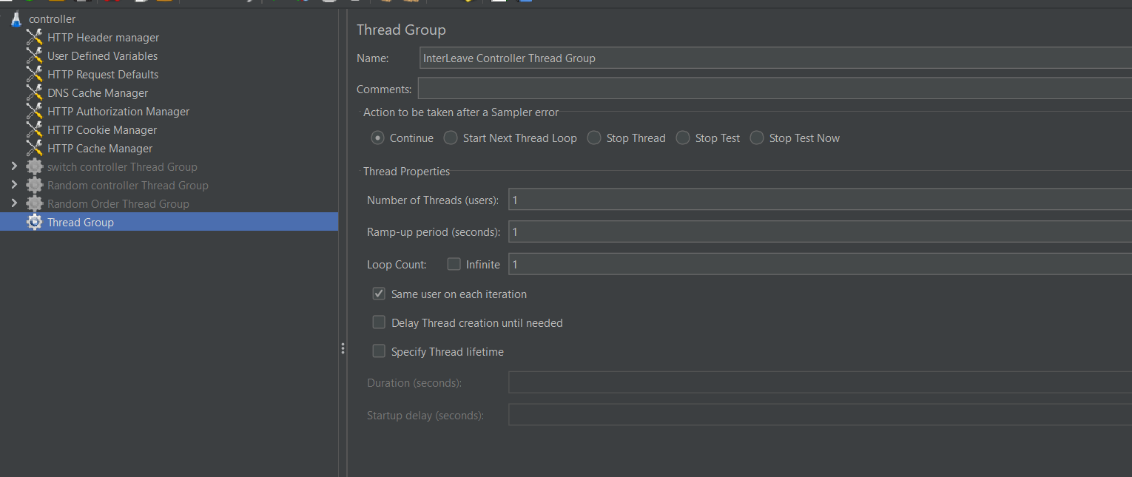

Adding interleave controller in Thread Group

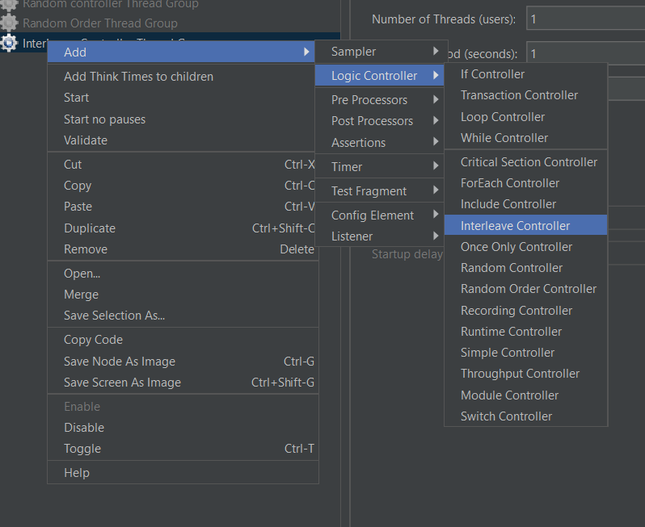

Adding simple control in interleave controller ,then adding scripts in simple control.

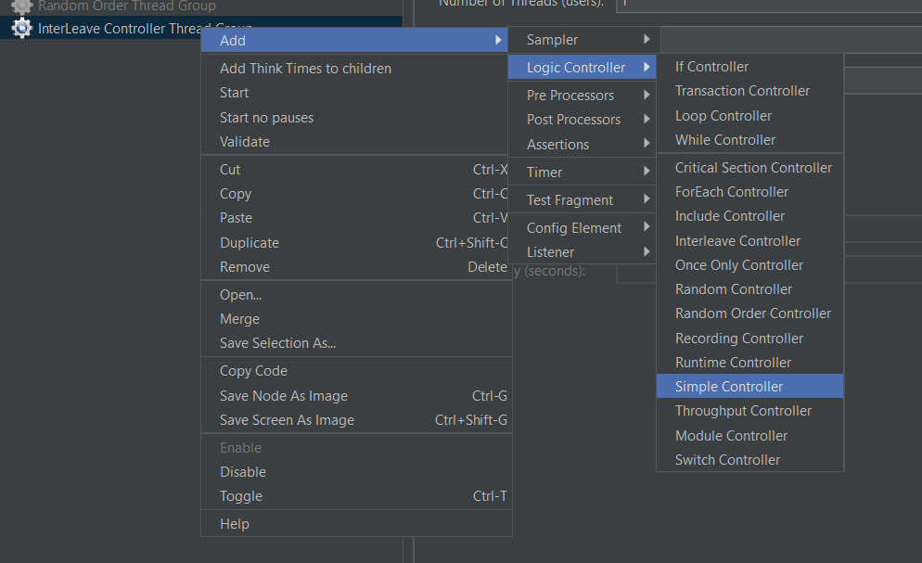

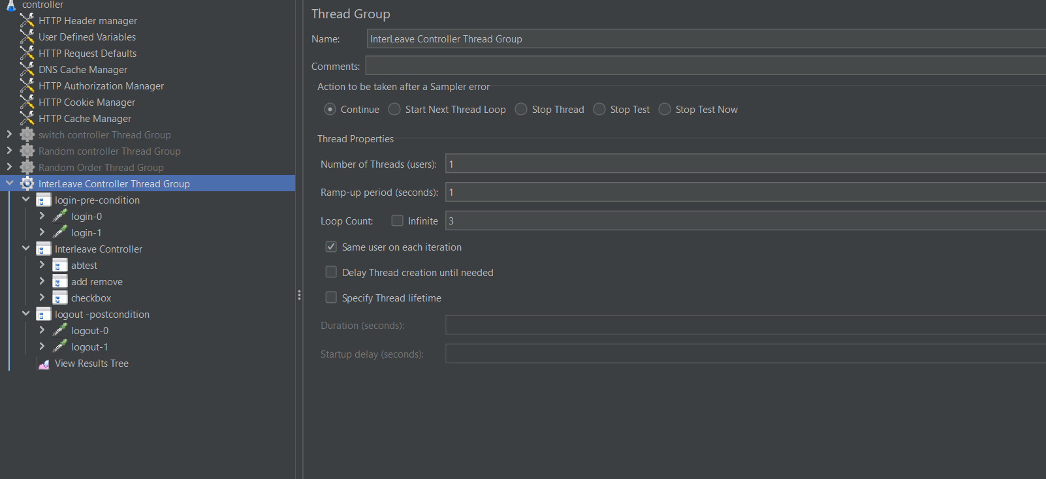

Running the script and execution is view in listener(view result tree)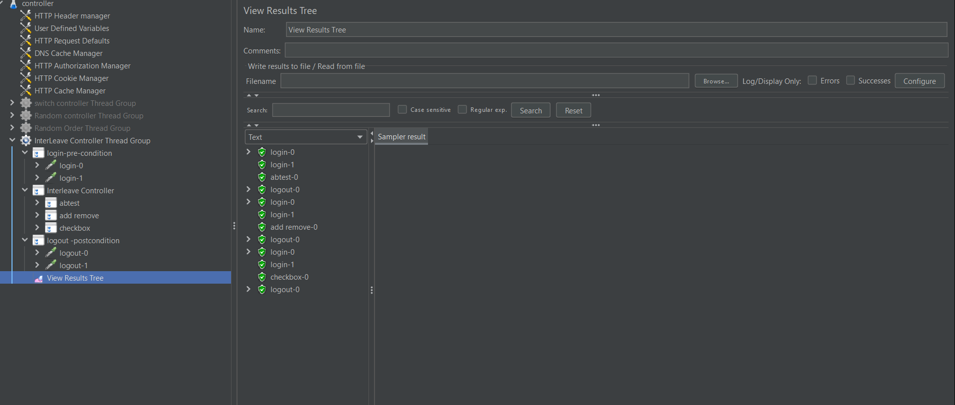

Since we gave loop count-3

There fore the script in interleave is execute in order ,In first loop 🡪first pre condition ,then second interleave controller script (first test case)then post condition script

In second loop 🡪 first pre condition ,then second interleave controller script (second test case) then post condition script